SELECT basics

1. SELECT population FROM world   
   WHERE name = 'Germany'

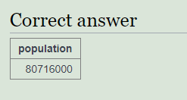

1. SELECT name, population FROM world

WHERE name IN ('Sweden', 'Norway', 'Denmark');

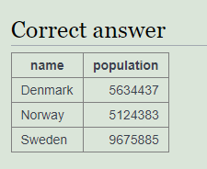

1. SELECT name, area FROM world

WHERE area BETWEEN 200000 AND 250000  
